1)Creating and Renaming Files/Directories

mkdir test_dir

cd test_dir

touch example.txt

mv example.txt renamed_example.txt

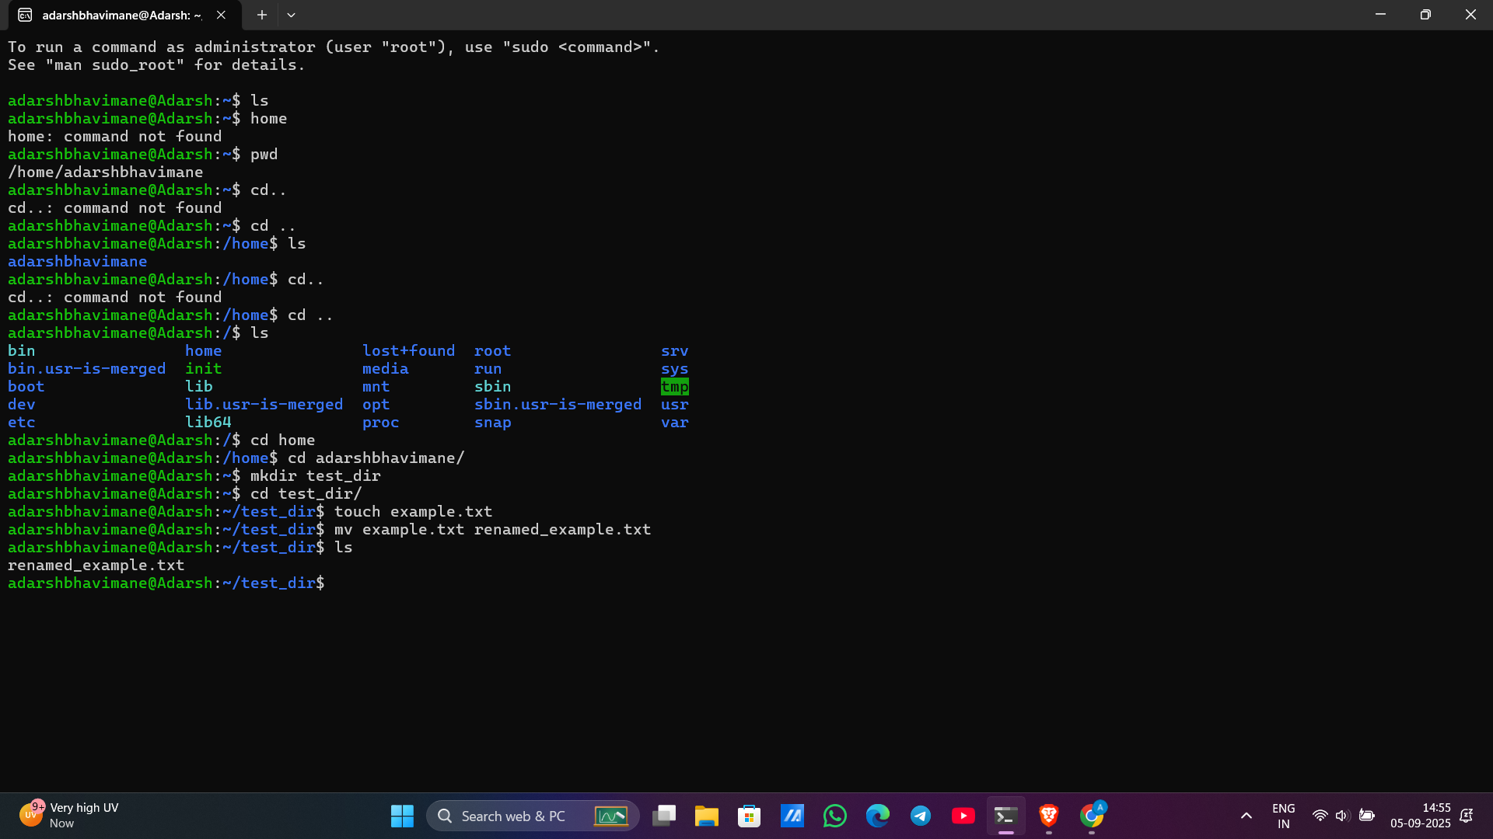  
I created a directory named test_dir, then created an empty file example.txt inside it.

Finally, I renamed the file to renamed_example.txt using the mv command.  
  
2. Viewing File Contents

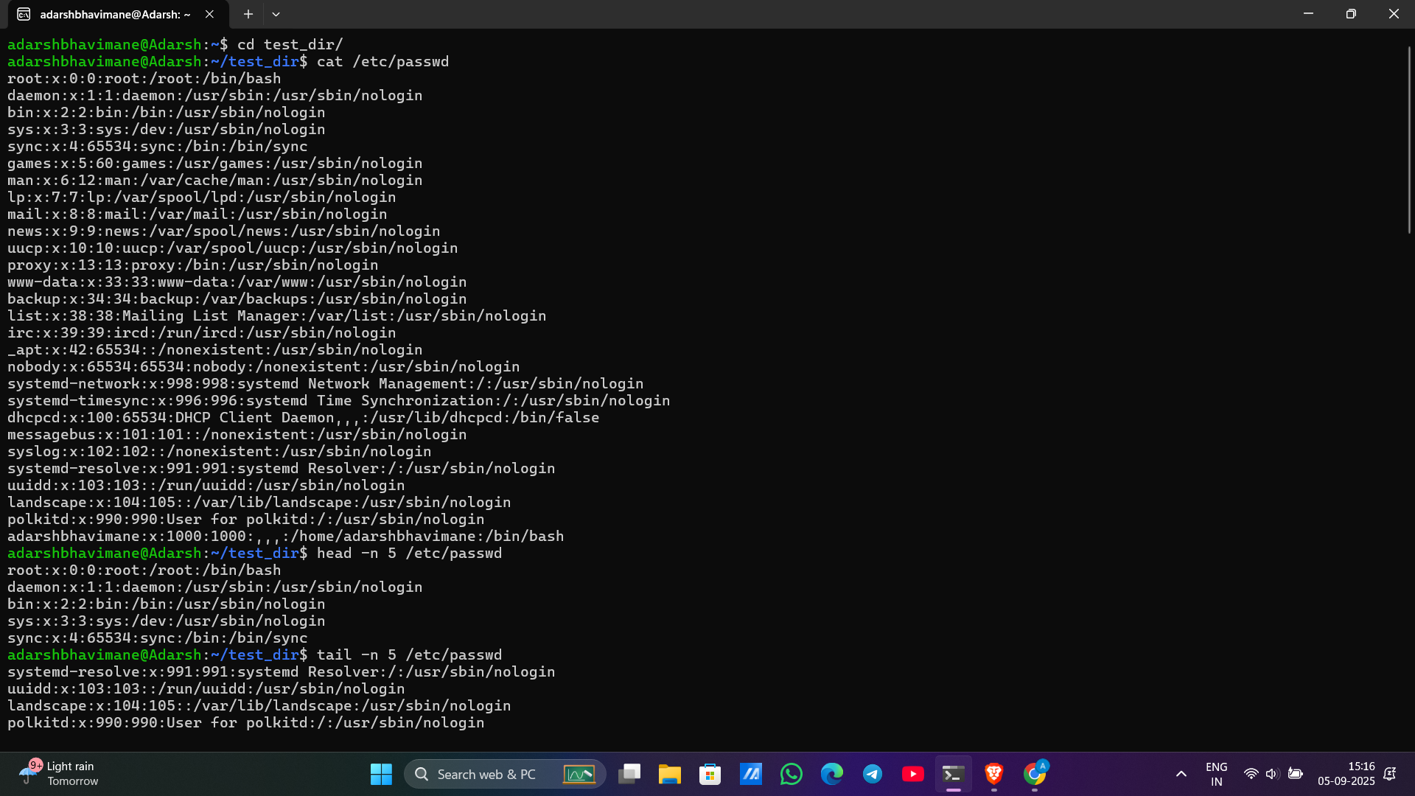

cat /etc/passwd

head -n 5 /etc/passwd

tail -n 5 /etc/passwd

I displayed the contents of /etc/passwd using cat.

Then I showed only the first 5 lines using head -n 5 and the last 5 lines using tail -n 5.

3.Searching for Patterns

grep "root" /etc/passwd



I used grep to search for the word "root" inside /etc/passwd.

It displayed all lines containing "root".

4. Zipping and Unzipping

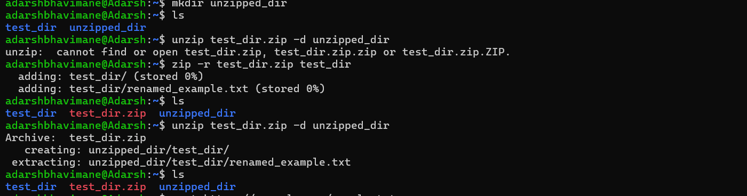

I compressed the directory test_dir into a file named test_dir.zip using zip -r.  
Then I created a new folder unzipped_dir and extracted the zip file into it using unzip

cd ..

zip -r test_dir.zip test_dir

mkdir unzipped_dir

unzip test_dir.zip -d unzipped_dir

5. Downloading Files

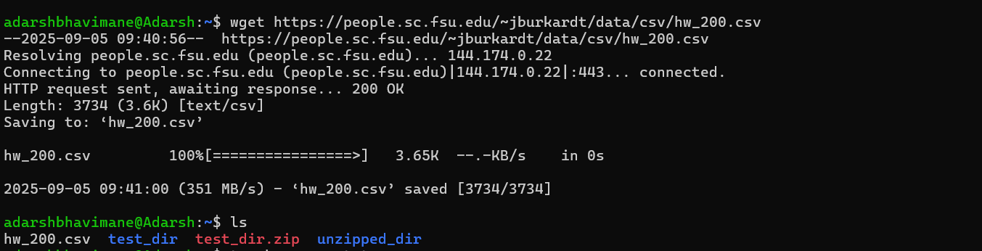

wget <https://people.sc.fsu.edu/~jburkardt/data/csv/hw_200.csv>  
  
I used wget to download a sample text file from the internet.

After downloading, I verified it by listing the file and displaying the first few lines.

6. Changing Permissions

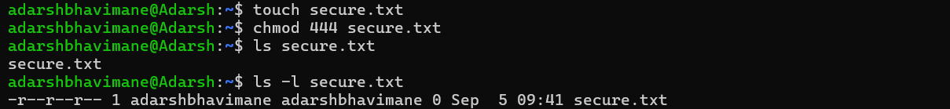

I created a file named secure.txt.

Then I changed its permissions to read-only for everyone using chmod 444.

Verified using ls -l

touch secure.txt

chmod 444 secure.txt

ls -l secure.txt

7. Working with Environment Variables

export MY_VAR="Hello, Linux!"

echo $MY_VAR

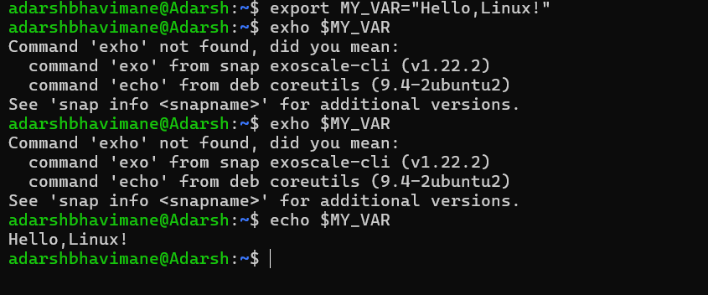

I created a new environment variable MY_VAR and assigned the value "Hello, Linux!" using export.

I confirmed it was set correctly using echo $MY_VAR.